NAME: _______________________________ Class: 6/__
UNIT 7 TELEVISION

I. Fill in the blank with appropriate letters.
1. pr_gr_m_e 2. c_med_ 3. n_ti_na_ 4. In_ell_ge_t
5. fa_ori__ 6. _han_el 7. F_nn_ 8. _w_ul
9. S_he_u_e 10. _eat_er_an 11. n__sr_ad_r 12. Ed_ca_iona_
13. S__p_d 14. _oc_l 15. C_nt_ol 16. Ch_r_c_e_

II. Rearrange the following letters to form the correct words.
1. pulpoar => popular 2. viel 3. ginrob 4. dogo
4. nufny 5. nolg 6. whos 7. lghau
8. loco 9. sabeceu 10. tub 11. Swen

III. Choose the correct conjunctions
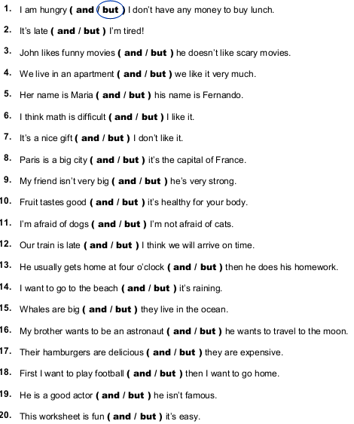
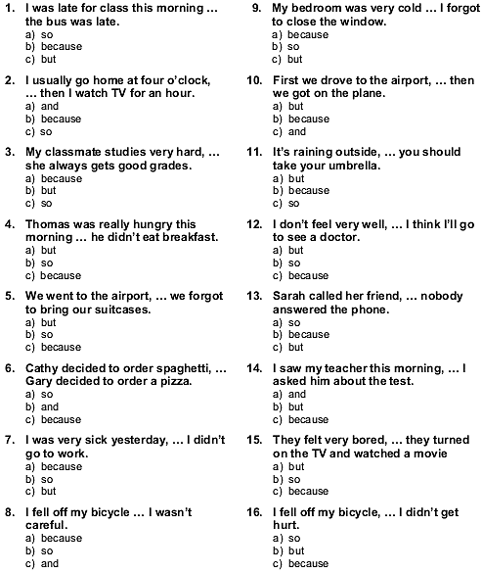

IV. Fill in the appropriate words in the blanks
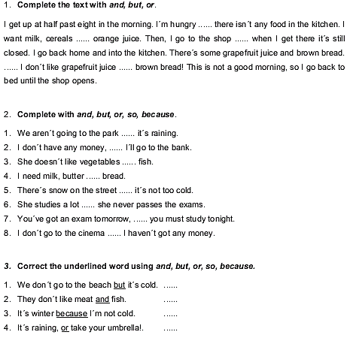

V. Fill in who, what, how, how many, when, where.
1. likes westerns? Brenda and John.
2. do you live? I live in a flat.
3. are your hobbies? Swimming and collecting stamps.
4. is your birthday? In April.
5. pens are there in the box? Ten, I think.
6. is good at English? Tom.
7. old is her son? Seven.
8. are your posters? Over my bed.
9. much is this pullover? Twenty pounds.
10. colour is your car? Red.
11. are you, Peter? I'm fine, thanks.
12. has got a pencil for me? Claudia has got one.
13. do you watch Tom and Jerry? On Sunday at 9.
14. is your fish tank? On my desk.
15. is her telephone number? 86 39 749.

Tiếng Anh lớp 7

I. Complete the second sentence so that it has a similar meaning to the first.
1. I usually stayed up late to watch football matches last year, but now I don’t.
I used .
2. There were some frees in the field, but now there aren’t any.
There used .
3. Linda doesn’t live with her parents any more.
Linda used .
4. He is not a poor man any more, but he becomes a rich businessman.
He used .
5. They didn’t often go to the cinema every Sunday last year.
They didn’t use .
6. My hair now is much longer than that in the past.
In the past my hair used .
7. I don’t have time to collect stamps as when I was in primary school.
I used .
8. Did you often go to the beach when you lived in Nha Trang?
Did you use .
9. Mr. Nam often went to work by motorbike, but now he goes to work by bus.
Mr. Nam .
10. There were traffic jams in this street during rush hours, but now the street becomes wider.
Th There
II. Choose the correct option for each gap in the sentences
1. Minh used to _____ his homework late in the evening.
A. does B. do C. doing D. did
2. If people _________ the rules, there are no more accidents.
A. follow B. take care of C. obey D. remember
3. You should _________ right and left when you go across the roads.
A. see B. look C. be D. take
4. Hurry up or we can't _________ the last bus home.
A. keep B. follow C. go D. catch
5. Lan used to go to school _________.
A. with bicycle B. by foot C. in car D. by bus
6. Public _________ in my town is good and cheap.
A. transport B. tour C. journey D. travel
7. _________ is not very far from here to the city center.
A. That B. This C. It D. There
8. When there is a traffic jam, it _________ me a very long time to go home.
A. costs B. takes C. lasts D. spends
9. Mai's dad usually drives her to school _________ her school is very far from her house.
A. but B. though C. because D. or
10. Yesterday Hoa and Lan _________ round West Lake. It took them an hour.
A. cycle B. cycles C. cycling D. cycled
III. Fill each blank with a word in the box
vehicles across did ride feels
break it rules accidents after

1. What _________ you do last Sunday?
2. I stayed at home and looked _________ my younger brother yesterday.
3. Does your bike ever _________ down on the way to school?
4. We must always obey traffic _________ for our safety.
5. How far is _________ from your house to the bus stop?
6. He used to _________ a tricycle when he was three years old.
7. Now there are more traffic _________ than there used to be in this city.
8. There did not use to be many _________ on the roads in my home town.
9. He lives in a small village in the mountains so he never _________ worried about traffic jams.
10. You should remember to walk _________ the streets at the zebra crossings.
IV. Read the conversation and answer the questions.
Hoa: Hi, Mary.
Mary: Hi, Hoa.
Hoa: What did you do last Sunday?
Mary: I when to the supermarket with my mother in the morning. In the afternoon, I cycled around West Lake.
Hoa: Oh, that sounds really healthy. How did you go to the supermarket?
Mary: My mother and I cycled there. We usually go to the supermarket by bicycle on Sunday. My father used to drive us there when I was small.
Hoa: Really? How far is it from your house to the supermarket?
Mary: It's about five kilometres.
Hoa: How long does it take you?
Mary: It's not long. About 15 minutes. I like cycling very much. Do you like to cycle around West Lake with me next Sunday?
Hoa: That sounds good. What time?
Mary: How about 2 p.m. at my house?
Hoa: OK. See you then.
Questions:
1. Does Mary usually go to the supermarket on Sunday?
.
2. Who does she usually go with?
.
3. How did she go to the market when she was small?
.
4. What's Mary's hobby?
.
5. What will Mary and Hoa do next Sunday?
.

Tiếng Anh lớp 8

REVISION
I. Stress:
1. A. dramatic B. physical C. poisonous D. permanent
2. A. factory B. contaminate C. environment D. pollution
3. A. visual B. thermal C. water D. pollute
4. A. medical B. hospital C. politic D. electric
5. A. physical B. horrific C. beautiful D. different
II. Choose the best answer to finish the sentence:
1. Noise pollution can lead to________loss.
A. looking B. hearing C. listening D. reading
2. If I________a millionaire now, I________travel around the world. But in fact, I am very poor and have no money.
A. were/ would B. am/ will C. were/ will D. am/ would
3. We should wear_______when you go to concerts or other loud events to reduce the effect of noise pollution.
A. earphones B. earrings C. earplugs D. ear drops
4. What is the main_______of visual pollution? - Because there are too many advertising billboards.
A. effect B. affect C. result D. cause
5. Many animals eat the_______and become sick.
A. litter B. energy C. aqua D. temperature
6. Ships spill oil in oceans and rivers. This results ________ the death of many aquatic animals and plants.
A. to B. in C. from D. at
7. The acid rain has caused ____________ to the trees in this area.
A. damage B. advantage C. pollutant D. environment
8. Households ________waste into the river so it is polluted.
A. damage B. lead C. lose D. dump
9. We have to pay a huge amount of money - three million dong for electricity a month ________we turn on the heater all the time.
A. because of B. due to C. although D. since
10. Have you come _______ solutions to this problem?
A. up to B. up with C. to with D. on to
III. Word form:
1. The____________fish are floating in the water. DIE
2. Do you know what_____________cause air pollution? POLLUTE
3. The river is________________by the dumping from nearby factories. CONTAMINATE
4. Noise pollution can also lead to headaches and high blood____________. PRESS
5. The music club made so much noise that the _______________ complained to its owner.
RESIDE
6. If we use water ________________, more people will have fresh water. CARE
7. Are all types of pollution __________________ to the health of humans and animals? HARM
8. The polluted water results in the ________________ of many aquatic animals and plants. DIE
9. Examples of primary ________________ are exhaust fumes from cars, soot from smoke and ash from volcanic eruption. POLLUTE
10. The ________________ of lakes, rivers, oceans or underwater causes water pollution. CONTAMINATE
IV. Rewrite sentences by combining two sentences into one sentence and using suggested clues:
1. The air is so dirty. I sneeze so much. CONDITIONAL SENTENCE TYPE 2
____________________________________________________________________________
2. Their children have birth defects. The parents were exposed to radiation. BECAUSE
____________________________________________________________________________
3. The air pollution causes breathing problems. LEADS
____________________________________________________________________________
4. The environment is polluted. Birds leave their habits and plants die. MAKES
________________________________________________________________________
5. Factories release fumes. The air people breathe gets polluted. DUE TO

Tiếng Anh lớp 9
PRACTICE EXERCISE- GRADE 9 ( 2)
I. Rewrite the sentences as directed:
1. She’s sorry she can’t go to your party.
I wish ………………………………………………………………………..
2. Many people don’t care about environmental problems.
I wish …………………………………………………………………………
3. Of course, I can’t go to the moon for a vacation.
I wish …………………………………………………………………………
4. Like many other people, I can’t read people’s minds
I wish …………………………………………………………………………
5. Lan would love to talk with famous people in the world.
I wish …………………………………………………………………………
6. I want to know every language in the world.
I wish …………………………………………………………………………
7. She would love to live in Paris.
I wish ………………………………………………………………………
8. I hate having to get up early in the morning.
I wish ………………………………………………………………………
9. I never have enough money to buy things I like.
I wish ……………………………………………………………………
10. My parents complain that the quality of the school is too low.
I wish ……………………………………………………………………
11."Does she know Robert?" he wanted to know.
→ He wanted to know ________________________________________
12."Don't try this at home," the stuntman told the audience.
→ The stuntman advised the audience _____________________________
13."I was very tired," she said.
→ She said __________________________________________________
14."Be careful, Ben," she said.
→ She told Ben _______________________________________________
15."I will get myself a drink," she says.
→ She says __________________________________________________
16."Why haven't you phoned me?" he asked me.
→ He wondered _______________________________________________
17."I cannot drive them home," he said.
→ He said _____________________________________________________
18."Peter, do you prefer tea or coffee?" she says.
→ She asks Peter ________________________________________________
19."Where did you spend your holidays last year?" she asked me.
→ She asked me __________________________________________
20.He said, "Don't go too far."
→ He advised her __________________________________________
21. The milkman brings bottles of milk to houses.
Bottles of milk ...........................................................................
22. How do people learn languages ?
How are.....................................................................................?
23. John will collect me at the airport. .
I …………..........................................................................
24. The manager must sign the cheque
The cheque ………...............................................................................
25. They kept me waiting for half an hour.
I………………...........................................................................
26. They are building a new ring road round the city.
A new ring road...................................................................................
27. We can’t wear jeans at work
Jeans.......................................................................
28. Will you invite her to your birthday party?
Will she ……………………………………………………………….?
II/ Word form:
- Alice had a _____________day at work and went to bed early. (TIRE)
- Food and clothing are _____________of life. (NECESSARY)
- His dream is to be an _____________like his father when he grows up. (ECONOMY)
- Japan is an _____________country. (INDUSTRY)
- She can find no _____________to her financial troubles. (SOLVE)
- She is extremely _____________ about the history of art. (KNOW)
- My tooth was really _____________, so I went to see the dentist. (PAIN)
- A holiday in America can be _____________cheap. (SURPRISE)
- Lucy got _____________quickly and went to work. (DRESS)
- We all looked _____________after the summer holiday. (HEALTH)
- Is PETRONAS Twin Towers the _____________building in the world? (HIGH)
- Is New York _____________from London? (DIFFER)
- Every week, there are two v from Hanoi to Nha Trang. (FLY)
- In the story, the tiger wanted to see the farmer's _____________. (WISE)
- I must clean this _____________floor. (DIRT)

